ENG 125 Collaborative Project: Footnotes in Brown
Footnotes in Brown: A non-exhaustive digital archive of student-selected allusions, images, and references in Richard Rodriguez's Brown: The Last Discovery of America, (2002) in the style of Norton Critical Editions.

Rationale and Backgrounder: Students will create a website at Wordpress to upload their footnotes to their assigned pages of Brown, a stylistically dense text that weaves race and ethnicity in with the arts, culture, and the historical record. By providing footnotes to this text, students will be participating in one of the oldest traditions in academia: explaining an author’s references and/or allusions to the reader in a non-invasive, numerical subscript system of literal footnotes, using the ‘Add Footnote’ feature in the References tab in any Word document.

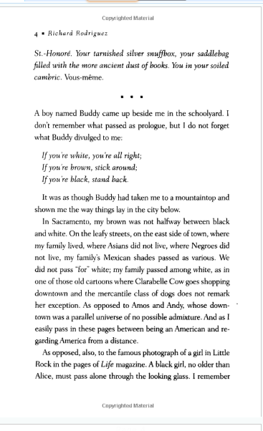
There will be one (1) website per class, that will be open to all students in that section to upload and/or copy paste their work. Over the semester of reading this nine (9) chapter book, students will be assigned single pages from each chapter that they will be responsible for finding, deciding on, and then looking up what Rodriguez is writing about. Students are thus doing research and creating context for the author’s boundless, wide-ranging, rich, and provocative references. For example, a student might be assigned page 4 of chapter 1 of Brown, “The Triad of Alexis de Tocqueville” in which Rodriguez finishes his imagined conversation with de Tocqueville from the previous pages, providing gorgeous imagery (the ‘tarnished snuffbox’; the ‘saddlebag’ full of ancient books; the ‘soiled cambric’), but the last words are in French: ‘Vous-même’ – clearly this would be an example of a foot-notable item that would help the reader keep up with the author. Another example for a foot-note-worthy item from this same page would be the reference to ‘a [black] girl in Little Rock’;
Here's what it would look like in practical terms:
Each student submits his/her nine (9) pages that have been annotated with at least four (4) footnotes; include links to BR sources where needed; at least one (1) of the footnotes per page has to be Substantive, containing both explication and analysis.
Student Name
p. 34 from Ch. 3 Brown, “The Prince and Me”
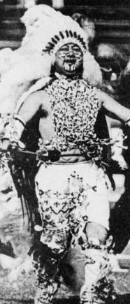
orchid¹
U.S. Census²
Prince Lightfoot/Timm Williams³
‘Unreal City’⁴
the pumpkin-colored settee (x2)⁵

___________
1 an orchid is a rare hot house flower; image of exotic beauty; non-native species
2 U.S. Census data asks questions about race and ethnicity; ‘Hispanic’ is considered an ethnicity, not a race
3 Prince Lightfoot aka Timm Williams was the Stanford University football team mascot in the 1960-70’s; he was at first very popular, but later on in his tenure as mascot, the native-American student organization protested his stereotypical costume and show (huge feathered Indian headdress, war paint, hatchet, on horseback, Indian war calls, etc.). Prince Lightfoot acts as a foil or juxtaposition to ‘the authentic’ Indian, with which Rodriguez contests and critiques. [SUBSTANTIVE] https://nacc.stanford.edu/about-nacc/history-timelines/stanford-mascot-timeline/removal-indian-mascot-stanford
4 Unreal City: Allusion to line and image in T.S. Eliot’s poem, “The Wasteland’; in the poem, London is the “Unreal City’ but in Brown, Los Angeles is the ‘Unreal City’; also, London fog is replaced by L.A. smog in this image https://www.poetryfoundation.org/poems/47311/the-waste-land
5 the pumpkin-colored settee – repeated image of an orange couch; theatrical prop on imagined stage set
More on the logistics:
ENG 125.059 MW 1-2:30 pm Brown Digital Archive will be called, ‘The Victors’;
The password for login will be UMVictors
ENG 125.060 MW 2:30-4 pm Brown Digital Archive will be called, ‘The Valiant’;
The password for login will be UMValiant
Graphic and Design Elements:
Every time you post a new set of footnotes, you will need to use basic design features including a centered, bolded title; and at least one (1) image, logo, gif, or picture that represents one of the terms you have footnoted.

‘Vous-meme’ is French for ‘you, yourself’; used emphatically.

